**SAINTGITS COLLEGE OF APPLIED SCIENCES**

**PATHAMUTTOM, KOTTAYAM**

**First Internal Assessment Examination, September 2018**

**B. Com Third Semester (Computer Applications & Taxation)**

**BUSINESS ETHICS AND CORPORATE SOCIAL RESPONSIBILITY**

Total: 50 marks Name ………………….

Time: 2 Hours Roll Number ……………

**Section A**

*Answer any 5 questions. Each question carries 2 marks.*

1. Define CSR.
2. What is Business Ethics?
3. Differentiate between Ethics and Law.
4. Explain the importance of Business Ethics.
5. What is ethical code?
6. What are the various ethical standards followed by a company? **(5 X 2 = 10 marks)**

**Section B**

*Short essay questions*

*Answer any 5 questions. Each question carries 5 marks.*

1. Explain arguments for and against social involvement of business.
2. Distinguish between business ethics and CSR?
3. Explain Corporate Philanthropy and Corporate sustainability.
4. Explain responsibility of business towards community.
5. Explain the various factors affecting Business Ethics?
6. Explain the foundations of Business Ethics. **(5 X 5 = 25 marks)**

**Section C**

*Long essay questions*

*Answer any 1 question. It carries 15 marks.*

1. Explain Ethical and Normative theories of Business Ethics.
2. What is CSR? Explain the responsibilities of business towards various interested parties.

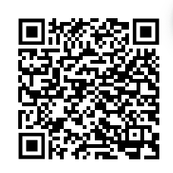 **(1 X 15 = 15 marks)**

***Scan QR code for the answer scheme***