**SAINTGITS COLLEGE OF APPLIED SCIENCES**

**PATHAMUTTOM P.O, KOTTAYAM**

**II Internal Examination –November 2018**

**B.Com Third Semester (Computer Applications and Taxation)**

**BUSINESS ETHICS AND CSR**

Total marks: 80 Name: ……………..

Time: 3 hours Roll No :……………

**Section A**

***Answer any 10 questions. Each question carries 2 mark.***

1. What is Cross –holder conflicts and competition in decision making?
2. What is Moral Philosophy?
3. What is corporate culture?
4. Define work ethics?
5. What is ethical dilemma?
6. What are the sources of ethical standards?
7. Define corporate governance.
8. What is corporate excellence?
9. What is GRI?
10. What is Environmental CSR?
11. What is Morality?
12. What do you mean by Spirituality?

(1 x 10 = 10 Marks)

**Section B**

***Answer any 6 questions. Each question carries 5 marks.***

1. What do you mean by Marketing ethics?
2. Explain Consumer Protection Act,1986?
3. Explain stages of Moral development by Lawrence Kohlberg.
4. Explain about consumer disputes redressal agencies.
5. What are the reasons for growth of corporate governance in India?
6. Explain ethical decision making models.
7. What are the goals of accounting ethics?
8. What are the prerequisites for implementing CSR?
9. Explain organizational culture.

( 2 x 8 = 16)

**Section C**

***Answer any 2questions. Each question carries 15 marks***

22. Explain forms of market structure and their roles in ethics .

23. Explain models of CSR.

24. Explain CSR provisions under the Indian companies Act,2013.

25. Explain ethical approaches?

(4 x 6 = 24)

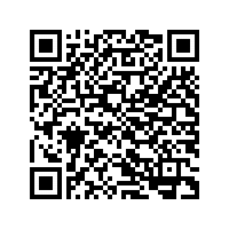

***Scan QR code for the answer scheme***